Product Announcement
HiFi Rose RS130
The ultimate network transport.
Didcot, Oxfordshire – 29th June 2023

Henley Audio is thrilled to confirm the UK availability of the HiFi Rose RS130 network streaming transport, the Korean company's new flagship source device. Building on its established industrial
design principles, HiFi Rose tunes its latest product to supply bona fide high-end performance levels while still focusing on offering the very best user experience possible.

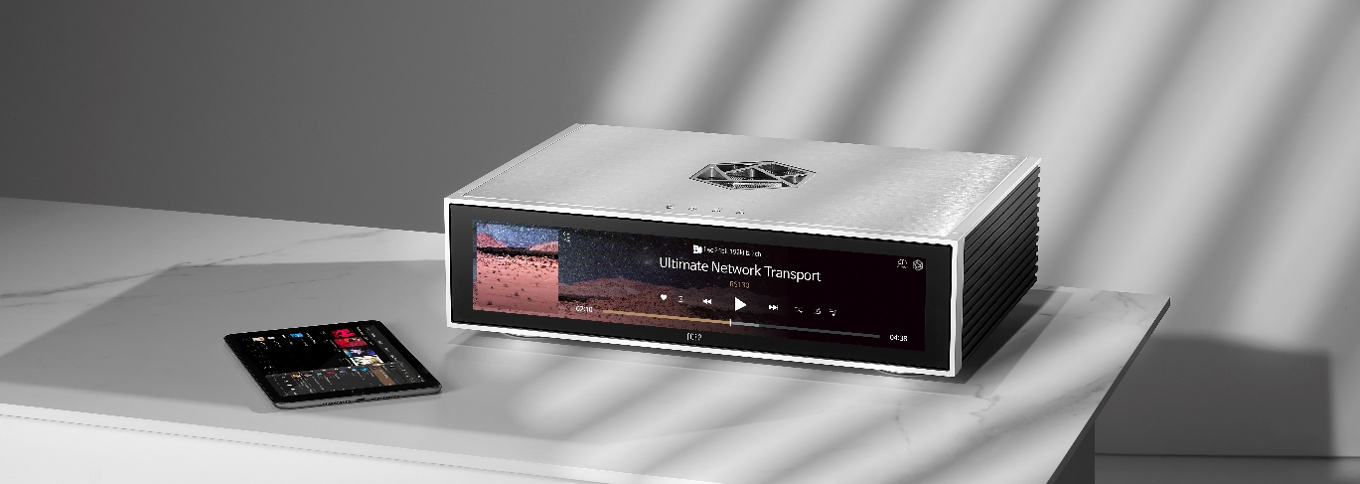

Unveiled to the world at the High End Munich show in May 2023, the RS130 is designed from the ground up to deliver a perfect digital signal to your preferred digital-analogue converter. Visually
striking, completely intuitive, and breathtaking in its sonic delivery, the RS130 is the ultimate network transport for any true audiophile.

Key features include:
- Advanced internal design optimised to minimise noise and interferences
- Benefits from the complete Rose OS operating system and Rose Audio Architecture
- Dedicated SSD for audio caching built-in, allowing for clean signal generation and low latency
- Linear power supply with high-capacity supercapacitors controlling power flow
- Luxury industrial design characteristics, including front-facing 15.4ʺ LCD touch-screen
- New fibre ethernet network connectivity option for greater transmission quality
- Sturdy aluminium chassis with ventilation built-in to the ROSE logo
- Support for external 10MHz master clocks via 50Ω and 75Ω terminals
- Support for fibre USB transmissions
- Support for Tidal, Apple Music, Qobuz, Spotify, Roon Ready, Rose Tube and more services
- Ultra-stable, high-precision OCXO clock built-in
- USB, Coaxial, AES/EBU, Optical and I2S Output options

HiFi Rose RS130: £4,299.00 (SRP)
RS130 will be available during July 2023 throughout the UK HiFi Rose dealer network.
Available in Black or Silver chassis finish.

HiFi Rose RS130 in detail

The RS130 is the ultimate network streaming transport. From its crystal-topped control buttons and intuitive touch-screen interface to its complex, performance-optimised inner workings, the flagship device suits anyone looking for the best possible way to send a whole world of digital audio content to their DAC.

No More Noise
The HiFi Rose design team's principal technical ambition when developing the RS130 was to produce a clean digital signal for any connected DAC, allowing for a low noise floor and a vivid, detailed sonic image. The Korean maker uses several new technologies to achieve its goal – including optical network connectivity, optical USB connection options and a high-precision OCXO clock – and stunning technical measurements achieved under laboratory conditions confirm the RS130's excellence.

Optical fibre data transfers are noise-resistant, fast, and reliable, even over longer distances.
Therefore, the RS130 supports sending and receiving data using Small Form Factor Pluggable (SFP) transceivers over ethernet. Similarly, fibre USB technology is more immune to electromagnetic noise and enhances signal stability, which is why the RS130 boasts a fibre USB 3.0 input. Further, HiFi Rose will also soon offer the RSA720 USB Hub with fibre output enabling this still-developing technology to upgrade the performance of any local, USB-attached music storage.

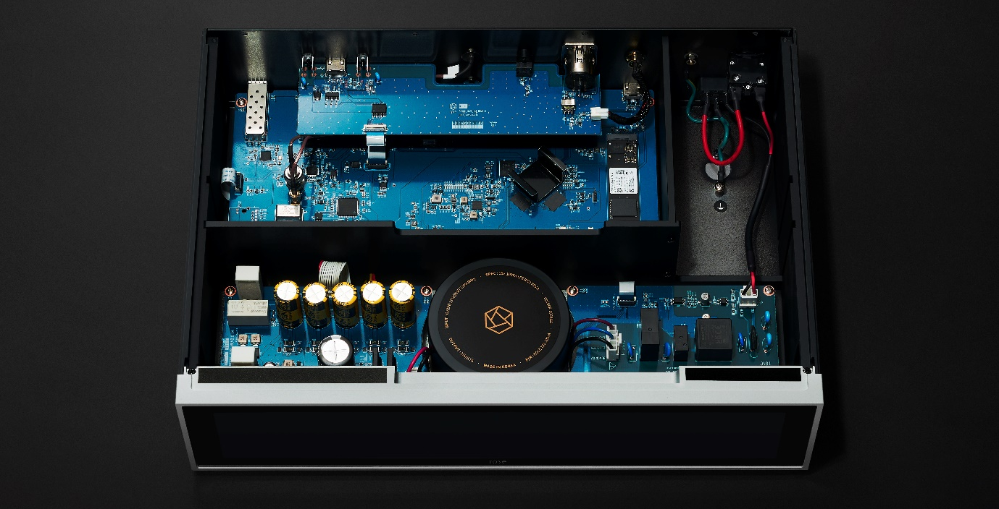

Keep In Time
The RS130 maximises the accuracy of its digital output signal by using a high-precision OCXO 10MHz clock. This type of clock is amongst the most accurate and stable on the current market, regardless of temperature changes, and is purpose-designed to suppress jitter generation. The result is perfect musical timing in the end performance, allowing listeners to travel deeper into the sound field. There's also an external master clock input for synchronising the clock signal between various devices.

Optimised Performance
Throughout the RS130 signal path, HiFi Rose's designers have selected premium components and technologies to ensure no part of the transport process is compromised. This logic even transfers to the actual board layout, where the AC power supply, DC power supply and audio-signal processing circuits are physically isolated from each other.

A newly designed 15V DC / 6.67A power supply section featuring high-capacity supercapacitors and a shielded linear power supply then feeds the entire circuitry. This innovative design provides excellent power delivery to the main audio circuitry, with sufficient headroom to ensure the power supply is never under stress and the performance is never compromised. The result is dramatically reduced power noise and a sonic performance from the RS130 that is natural and faithful to the original.

A Build to Behold
Externally, the RS130 is instantly identifiable as a luxury industrial design. Functional heat-management aspects, such as the heat-sinks on the chassis side and the built-in ventilation to the HiFi Rose logo on the top, complement the solid aluminium construction. It is also highlighted by striking visual elements, such as the crystal-topped control buttons on top of the unit, and the wide-angle 15.4" 1920*382 resolution LCD capacitive touch-screen, making the device a joy to use day after day.

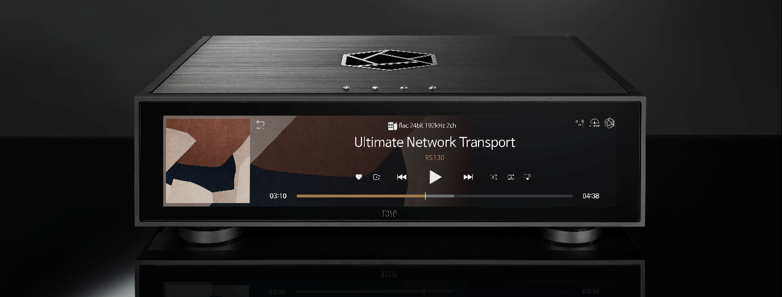

Rose OS
At the centre of the RS130 experience is ROSE OS, HiFi Rose's Android-based operating system, which opens up a world of music and video to your streamer.

Rose OS allows users to play music and video files from a local storage device (USB, MicroSD or SATA) or access files elsewhere on their home networks with a DLNA connection to any NAS drives or other storage devices. The Music app presents all your connected music storage and is a joy to navigate. Rose OS also features built-in apps for Tidal, Qobuz and Apple Music, giving complete access to their extensive streaming libraries. The Tidal app even provides access to the service's music video
streaming content for playback on the RS130 screen or via its HDMI output. On top of this impressive feature set, the RS130 fully decodes MQA, enabling maximum-quality playback of Tidal Masters tracks.

Elsewhere, the CD and CD Ripping apps allow you to attach any standard external CD-ROM drive for convenient CD playback – or to rip CDs in the highest quality to any local storage device quickly and intuitively – all through the touch-screen interface. The Radio and Podcast apps give you access to extensive live radio and podcast databases, while Rose Tube gives you access to YouTube for music and video playback. Rose OS also supports Roon Ready, Spotify Connect and Apple AirPlay, effectively bringing your entire digital audio experience into one elegant system.

In addition to offering extensive music access, Rose OS facilitates high-performance sound. The Rose Audio Architecture* within Rose OS can deliver pure audio data to a DAC without loss, thanks to the Rose Audio Server, developed in-house by HiFi Rose to utilise various signal processing technologies. These technologies separate the audio data from all other processes required to run the operating system, meaning the audio signal is never affected when controlling different aspects of the RS130.

The RS130 employs a dedicated 256GB SSD for audio caching, eliminating the impact of vibrations and noise that can occur when playing audio from a hard drive connected via USB. This feature also minimises latency errors that can happen during network streaming, allowing for more stable caching and playback, which prevents audio quality degradation.

Connect what you need
The RS130 flagship commands your digital audio system. As such, it boasts extensive connectivity, including more traditional Coaxial, Optical and AES/EBU outputs, alongside an Audio USB output and a selectable I2S output. The HDMI video output neatly lets you play video or music information on a connected screen. The EXT Clock BNC inputs allow clock synchronisation, and the USB inputs allow local music storage attachment. The USB 3.0 Fibre port can only be used by connecting an SFP module and using an external USB 3.0 Fibre Hub – such as the HiFi Rose RSA720 CD drive – and an optical cable. Users can also utilise the 10/100/1000 BASE-T Ethernet port with SFP Fibre and Copper modules for appropriate network connectivity.

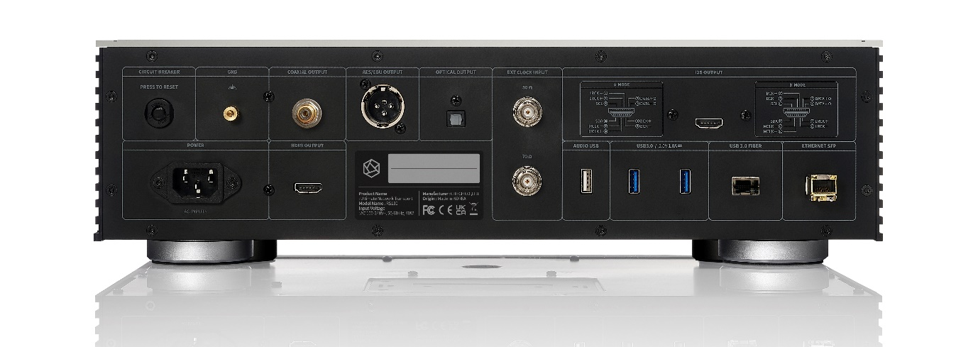

The Ultimate
The RS130 has been designed from the ground up to function as the ultimate network transport
device. Brimming with innovative technologies and industrial design characteristics, it delivers perfect digital audio to any connected DAC, resulting in a natural sound, free of unwanted noise and shaped only by the influence of your chosen DAC.

*Rose Audio Architecture Explained:
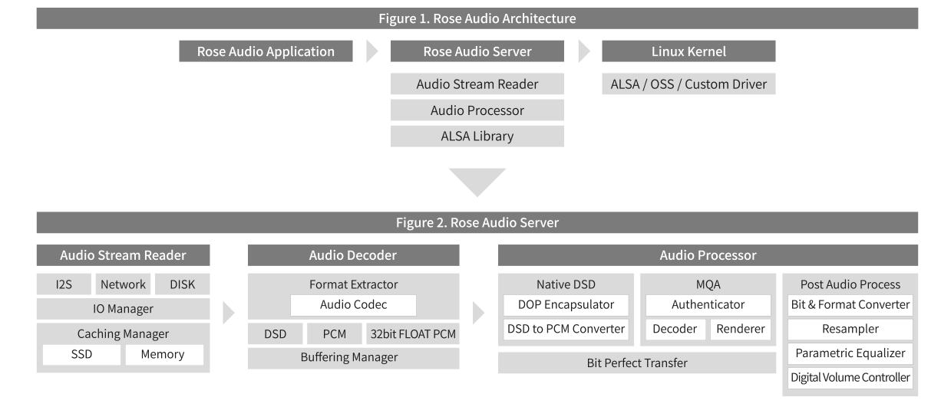

Technical Information

Base Operating System: Customised Android 7.1
Main Chipset: RK3399(28nm HKMG Process)
Six-Core ARM® 64-bit processor,
up to 2.0GHz Based on Big.Little architecture,
Dual-Core Cortex-A72 and Quad-Core Cortex-A53 with separate NEON coprocessor
ARM Mali-T860 MP4 Quad-Core GPU
Memory (DRAM): LPDDR4 Dual-Channel 4GB
Memory (Flash): 8GHz High-Speed eMMC
M.2 M-key 256MB NVMe
External SSD Supported

Control Buttons: Power / Mute / Favourites / Play-Pause
Display: TFT LCD 15.4” 1920 x 382 pixels(eDP)
Active area: 381.888 x 75.97mm
Capacitive touch
IR Controller: 38kHz IR receiver port

BNC Input: 50Ω / 100Ω inputs for 10MHz clock
HDMI Output: HDMI 2.0 4K x 2K 60Hz display resolutions
I2S HDMI Output: 32-bit / 768kHz possible – selectable between A & B configurations
S/PDIF Optical Output: 24-bit / 192kHz possible
AES/EBU Output: 32-bit / 384kHz possible
Coaxial Output: 32-bit / 384kHz possible

Size: 430 x 317 x 125 mm
Weight: 11.7kg

Notes for Editors
Consumer Contact for Publication
Henley Audio Tel: 01235 511 166
Didcot, Oxfordshire Email: sales@henleyaudio.co.uk
Web: www.henleyaudio.co.uk


About HiFi Rose
HiFi Rose aims to take you "beyond audio". It makes products that sound exceptional and are a joy to experience in aesthetics and operation. The flagship RS130 sets the standard for this aim and delivers on all fronts one of the most innovative streaming devices the hi-fi industry has seen in recent years. The range was expanded in 2022 with the addition of the RA180 integrated amplifier, delivering astonishing specifications and new technologies in a more traditional market sector.

HiFi Rose is a division of Citech, a Korean software company originally founded in the 1960s. HiFi Rose assembles all its products in Korea.



About Henley Audio
Henley Audio has been importing and distributing industry-leading hi-fi equipment to the UK and Ireland since 1997. With a passion for great sound and a firm focus on brand integrity, we work to deliver excellence in both product and service.

Formed as the result of a management buy-out of Ortofon UK, Henley Designs Ltd. (trading as Henley Audio) operates in-house sales, marketing, service, support, and warehouse teams to offer the full turn-key solution for suppliers. The brands we represent are not only highly regarded in their own right, but they also share a symbiotic relationship with other brands in our portfolio.

For more information, visit www.henleyaudio.co.uk

Press Contact
Simon Powell
Henley Audio, Unit B, Park 34, Collett, Didcot, Oxfordshire, OX11 7WB
Tel: 01235 511 166
Email: simon@henleyaudio.co.uk
Web: www.henleyaudio.co.uk

